Network Devices solved questions

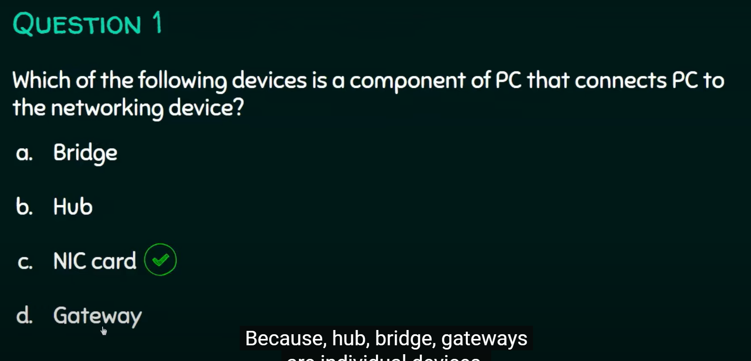

NIC = Network Iterface card

